**Design**

**Structure:**

Tasked to create an app to act as a single point of contact for our partners clients we needed to find a design solution that would cater to the technical requirements and user base. Through the process of designing the portal there were some alternative consideration for the final design, from observations of already existing apps of a similar function to our own design iterations.

**Description and Process:**

In regard to the design process it wasn't really a case of there being multiple different development routes and the need to analyse different iterations to generate a final design. However as a point of reference in developing the platform our industry partner recommended looking at MyPotteryApp (<http://www.mypotteryapp.com/features.html>) as a base to start our designs. Upon investigating the app, it was evident that there were technical similarities between the app and our task, but the style of the app seemed dated and we thought we could do better.

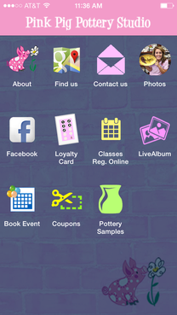

Seen above the home page for a studio supported

by MyPotteryApp uses a mix of different styled icons

which do not help with the continuity of style.

Regarding the low fidelity sketches of our design there were few issues and few details that did not make it to the final design. As the nature of these sketches were to be a simple representation of each page of the platform having a clear understanding of the problem ensured there were no issues creating accurate and relevant mock-ups.

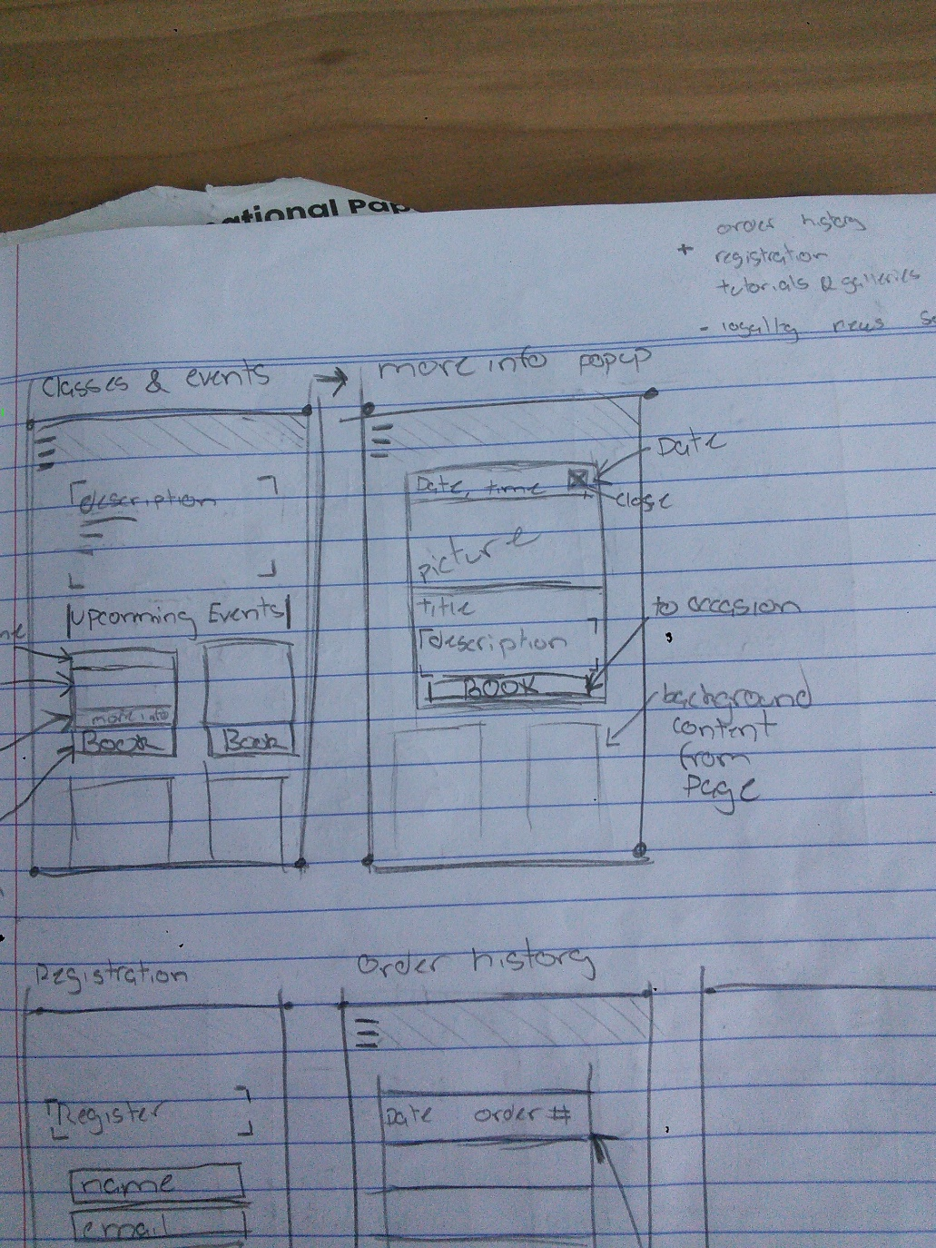

A snapshot of some of the prototypes above shows designs that will change little in the final iteration.

Working on the high-fidelity designs there was some trial and error specifically regarding colour schemes. Our initial Goal was to incorporate each of the three colours of the business logo into the platform design. After some trial with this however these colours contributed to making the design look messy and ultimately unnecessary in producing an easy to use design.

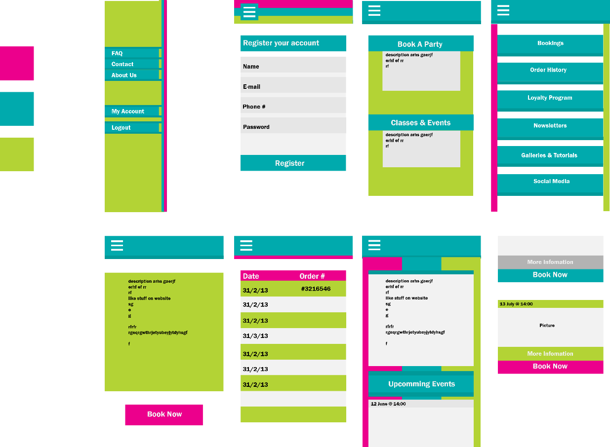

**Preferred Approach**

Ultimately, we settled on a design with a simple two-tone colour scheme. One where there would be no excess of colour detracting from the key information on each page. Along with this each page is designed with a single purpose in mind, to display only the necessary information for each page without excess links or data not relevant to the dedicated page. As we were keeping usability in mind creating a simple interface for the customers was important. So one factor we tried to replicate were some of the layouts of the current system the business is working with such as the layout of the booking system.

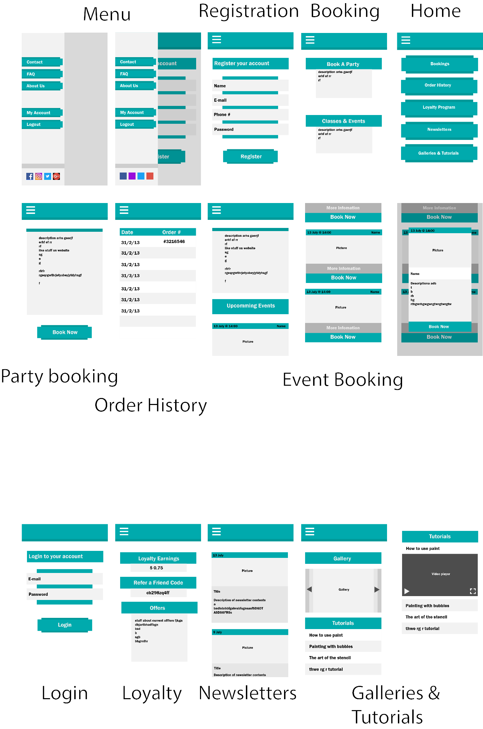

**Quality and Metrics**

The task of creating the platform design was housed in a single user story for platform design though we went over time on the allocated estimate we managed to produce a product that our partner was pleased with and we could build upon during the implementation to the system in semester two. Ultimately, we believe that the design we produced is better that the alternatives explored for the following reasons:

* Superior readability
* Simple selection of colour
* Easy to follow layout

Though we are happy with the result the scheme of colour does not entirely for the identity of the art studio we are representing, somewhat causing a confliction between app design and brand identity.